In Memoriam: Daniel Ray England, 1936-2011

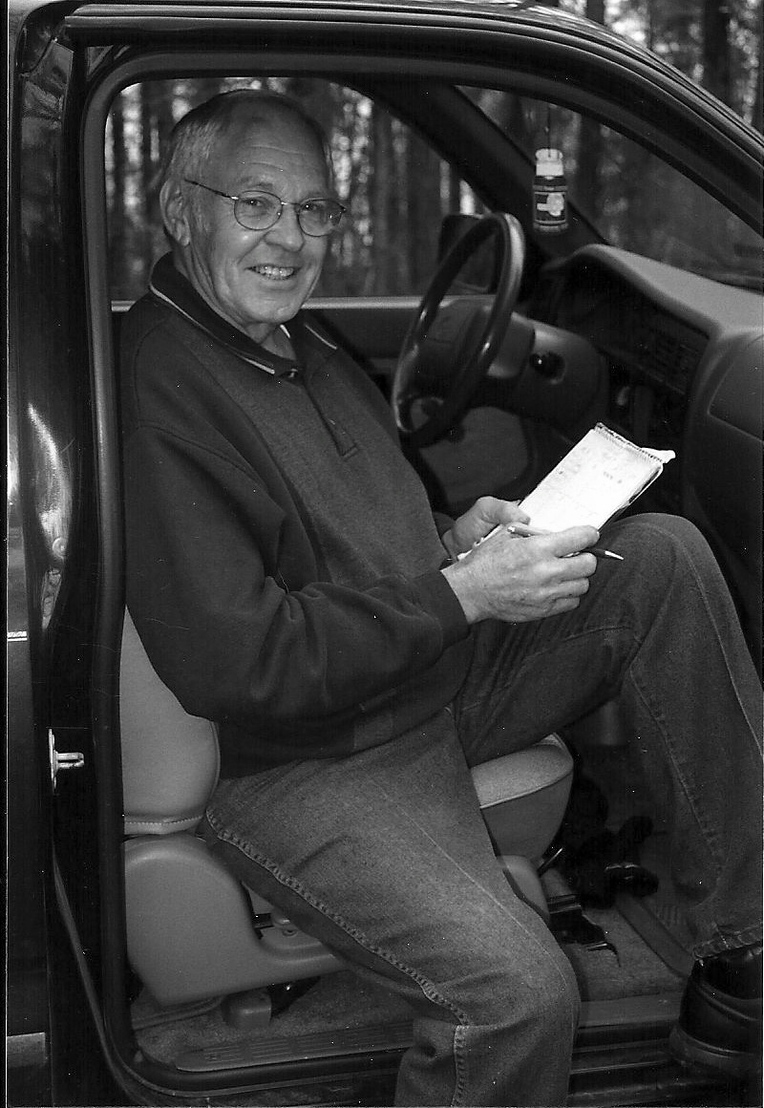

Dr. Daniel Ray England was born in the tiny rural hamlet of Couch, Missouri on May 26, 1936, one of nine children. Although poor, his parents valued education and encouraged all seven boys and two girls to attend college. All nine children graduated from college with either a Master’s or Ph.D. degree. Dan graduated from Couch High School in 1954 and received his BSE degree from Arkansas State College at Jonesboro in 1961. After graduation from ASC, Dan taught high school biology from 1957-1966 variously in Missouri in Bakersfield, Matthews, and West Plains Public School Systems and spent 1966-1967 teaching biology in Pattonville, Texas. Dan served in the Army National Guard from 1959-1965. He earned both his MSE in Science Education and Ph.D. in Biology from Texas A&M University in 1968 and 1973, respectively. His doctoral dissertation was entitled, “The Phylogeny of the Order Carnivora, Based on Cerebral Structure.”

Dan came to Southern Arkansas University (then SSC) in September 1972 as Assistant Professor of Biology. He was promoted to Associate Professor in 1976 and served as Chair of the Department of Biological Sciences for over 10 years beginning in 1979. In 1982 he was promoted to full Professor. During his tenure at SAU Dan served on numerous committees, both standing committees and those special ones appointed by the President and or Vice-President, due to his reputation for hard work, dependability, intellect, ability to arrive at consensus, and wide-ranging experience in education. Dan was later honored by his colleagues as Honor Professor, the highest honor a faculty member can attain at SAU.

Dan England was an educator’s educator. He was a superb teacher, an excellent classroom lecturer, and always prepared for lecture and laboratory. He taught Comparative Anatomy, Embryology, General Biology, as well as several graduate courses such as Biology for Teachers. In addition, he served on the graduate committees of several SAU graduate students. As a teacher, his reputation was “tough, but fair” and he always assisted any student who needed his help. His biology majors went on to teach biology in both middle school and high school at numerous area schools, medical school, and various professional schools to continue their higher education. Dan was an Associate member of the Society of the Sigma Xi and was a Life Member of the Arkansas Academy of Science. He regularly attended AAS meetings from 1973 until his retirement.

After retirement Dan continued work in the Advising Center at SAU assisting freshmen making important decisions about schedules. Academically after retirement, Dan served as a faculty member (1995-2003) on the popular OutWest trips of Mr. Tim Daniels (SAU) sponsored by the South Central Services Coop which annually took 40 teachers on a western trip for which they earned graduate credit. In other areas, Dan enjoyed working outside and gardening. He became interested in buying and restoring Farmall Cub Tractors. This interest led him to the farmall.com forum where he made many friends. Dan and his wife, Janie, traveled to Texas to gather with these friends at the club meeting where some would show off their restored tractors. Others would sell and trade tractors and parts.

I (DAS) met Dr. Dan England during the summer of 1988 after he contacted me regarding the presence of Rafinesque’s bats in abandoned houses and water wells. Dan did not consider himself a field research biologist and certainly not a bat biologist but this chance meeting would change all that as he and I bounced along the country roads of southern Arkansas for the next 12 years. During that time we forged one of the best and most meaningful friendships of my life and not a day goes by that I do not think of him. Our first day in the field was pretty quiet as we sized each other up. Dan and I had briefly chatted at Arkansas Academy of Science Annual Meetings, but never had we been cooped up in a Honda Civic for 12 hours. Dan was very reserved and had a distinguished air about him and I thought this “odd couple” partnership would never work. However it wasn’t long before our many adventures in the field and their re-telling and my stories of field mishaps elsewhere would find us laughing to the point of tears with Dan often doubling over holding his side. I am truly amazed we were never stopped by law enforcement and asked to take some type of sobriety test because we always had way too much fun traveling between sites. During our 12 years of fieldwork Dan and I met at least once a month and often 4 times a month from May through August when bats were pregnant or pups present at maternity sites. We once calculated we had spent one solid year of our lives and had driven nearly 75,000 miles during our study.

Dan and I investigated Rafinesque bats in many structures and had many memorable experiences. In an industrial park at Camden, Arkansas we were given permission to enter cavernous, underground, solid concrete WWII gun powder storage structures that had such good acoustics one could literally hear a pin drop. Inside one of these nested a vulture unseen by us in the dim glow of our headlamps. As the bird began to fly towards the exit and us, the low whooshing sound of the long wing-beats, magnified many, many times and accompanied by ghoulish hissing had us running for the exit like our hair was on fire. On another occasion Dan positioned my legs under his arms as I leaned over and down inside a 30 foot deep abandoned water well while trying to remove a bat from the well’s wall. As Dan hoisted me up the silence of the winter roost was broken by the sound of Velcro opening on my vest pocket followed by the tinkling of car keys as they tumbled into the dark water below. Dan and I managed to catch a ride to his parked vehicle located miles away and, interestingly, the only time we ever had two vehicles in the field. We drove to Radio Shack in Camden where we purchased a large magnet and a spool of twine then spent the remainder of the day fishing for car keys.

Dan England was low key, a long-time member of the Academy and always operated under the radar. He had no desire to be the presenter of research findings at meetings and never sought recognition or the spotlight for his efforts. His fieldwork on Rafinesque’s bat has and continues to yield valuable natural history information about this sensitive species through existing and planned publications.

I (HWR) first met Dan in 1972 when he replaced Avalee Cox in our department. We hit it off immediately and remained best friends for over 40 years. Dan was a dear friend, a trusted confidant, a superb college biology teacher, a friend of and advisor to students, a devoted husband, father, and grandfather, and one of the most ethical scientists I have ever known. Dan’s goal coming out of graduate school was “to teach biology at a teaching oriented college” and I suspect that he succeeded even beyond his original dreams. We will miss our dear friend and faithful colleague.

In putting together this memoriam, we are indebted to Ms. Sarajane Telford and Mr. Tim Daniels of Southern Arkansas University, both friends of Dr. England, for providing information on Dan’s career as well as to the England family for supplying important biographical information.

Henry W. Robison, 9717 Wild Mountain Drive, Sherwood, AR 72120.
David A. Saugey, 1173 Hwy 298, Jessieville, AR 71949.

